ASSIGNMENT 3.1

2303A51574

BATCH-29

Question 1: Zero-Shot Prompting (Palindrome Number Program)
Write a zero-shot prompt (without providing any examples) to generate
a Python function that checks whether a given number is a palindrome.
Task:
• Record the AI-generated code.
• Test the code with multiple inputs.
• Identify any logical errors or missing edge-case handling.

CODE:
def is_palindrome(number):
# Convert input to string and remove any potential whitespace
str_num = str(number).strip()
# Check if string is equal to its reverse
return str_num == str_num[::-1]

# Get user input
user_input = input("Enter a number to check: ")

if is_palindrome(user_input):
print(f'{user_input} is a palindrome.')
else:
print(f'{user_input} is not a palindrome.')

OUTPUT:
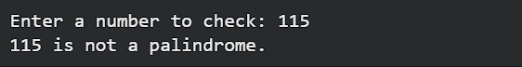

Question 2: One-Shot Prompting (Factorial Calculation)
Write a one-shot prompt by providing one input-output example and
ask the AI to generate a Python function to compute the factorial of a
given number.
Example:
Input: 5 → Output: 120
Task:
• Compare the generated code with a zero-shot solution.
• Examine improvements in clarity and correctness.

CODE:
def factorial(n):
if n < 0:
return "Factorial is not defined for negative numbers"
elif n == 0 or n == 1:
return 1
else:
return n * factorial(n - 1)

# Get user input
try:
user_num = int(input("Enter a number to find its factorial: "))
result = factorial(user_num)
print(f"The factorial of {user_num} is {result}")
except ValueError:
print("Please enter a valid integer.")

OUPUT:

Question 3: Few-Shot Prompting (Armstrong Number Check)
Write a few-shot prompt by providing multiple input-output examples
to guide the AI in generating a Python function to check whether a
given number is an Armstrong number.
Examples:
• Input: 153 → Output: Armstrong Number
• Input: 370 → Output: Armstrong Number
• Input: 123 → Output: Not an Armstrong Number
Task:
• Analyze how multiple examples influence code structure and
accuracy.
• Test the function with boundary values and invalid inputs.

CODE:
def is_armstrong(number):
# Convert to string to easily iterate through digits
num_str = str(number).strip()
num_digits = len(num_str)

# Calculate the sum of digits raised to the power of num_digits
try:
total_sum = sum(int(digit) ** num_digits for digit in num_str)
return total_sum == int(num_str)
except ValueError:
return False

# Get user input
user_input = input("Enter a number to check if it is an Armstrong number: ")

try:
val = int(user_input)
if is_armstrong(val):
print(f"{val} is an Armstrong number.")
else:
print(f"{val} is not an Armstrong number.")
except ValueError:
print("Please enter a valid integer.")

OUTPUT:
Question 4: Context-Managed Prompting (Optimized Number
Classification)
Design a context-managed prompt with clear instructions and
constraints to generate an optimized Python program that classifies a
number as prime, composite, or neither.
Task:
• Ensure proper input validation.
• Optimize the logic for efficiency.
• Compare the output with earlier prompting strategies.

CODE:
import math

def check_number_type(n):
if n <= 1:
return "neither prime nor composite"

# Check for divisors from 2 up to the square root of n
is_prime = True
for i in range(2, int(math.sqrt(n)) + 1):
if n % i == 0:
is_prime = False
break

if is_prime:
return "a prime number"
else:
return "a composite number"

# Get user input
try:
user_input = input("Enter a positive integer: ")
val = int(user_input)

if val < 0:
print("Please enter a non-negative integer.")
else:
result = check_number_type(val)
print(f"{val} is {result}.")
except ValueError:
print("Please enter a valid integer.")
OUTPUT:
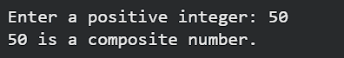
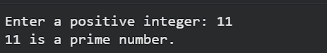
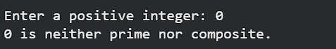
Question 5: Zero-Shot Prompting (Perfect Number Check)
Write a zero-shot prompt (without providing any examples) to
generate a Python function that checks whether a given number is a
perfect number.
Task:
• Record the AI-generated code.
• Test the program with multiple inputs.
• Identify any missing conditions or inefficiencies in the logic.
CODE:
def is_perfect_number(n):
if n <= 0:
return False

# Find divisors and sum them
divisors_sum = 0
for i in range(1, n):
if n % i == 0:
divisors_sum += i

return divisors_sum == n

# Get user input
try:
user_input = input("Enter a number to check if it is a perfect number: ")
val = int(user_input)

if val <= 0:
print("Please enter a positive integer.")
else:
if is_perfect_number(val):
print(f"{val} is a perfect number.")
else:
print(f"{val} is not a perfect number.")
except ValueError:
print("Please enter a valid integer.")
OUTPUT:
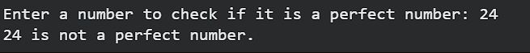
Question 6: Few-Shot Prompting (Even or Odd Classification with
Validation)
Write a few-shot prompt by providing multiple input-output
examples to guide the AI in generating a Python program that
determines whether a given number is even or odd, including proper
input validation.
Examples:
• Input: 8 → Output: Even
• Input: 15 → Output: Odd
• Input: 0 → Output: Even
Task:
• Analyze how examples improve input handling and output
clarity.
• Test the program with negative numbers and non-integer inputs.
CODE:
def is_perfect_number(n):
if n <= 0:
return False

# Find divisors and sum them
divisors_sum = 0
for i in range(1, n):
if n % i == 0:
divisors_sum += i

return divisors_sum == n

# Get user input
try:
user_input = input("Enter a number to check if it is a perfect number: ")
val = int(user_input)

if val <= 0:
print("Please enter a positive integer.")
else:
if is_perfect_number(val):
print(f"{val} is a perfect number.")
else:
print(f"{val} is not a perfect number.")
except ValueError:
print("Please enter a valid integer.")

OUTPUT:

